12.83: Divide the rod into differential masses dm at position l, measured from the right end of the rod. Then, 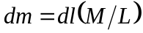, and the contribution 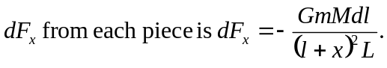 Integrating from 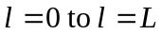 gives

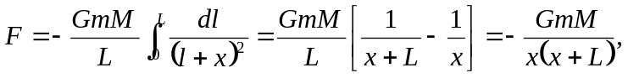

with the negative sign indicating a force to the left. The magnitude is 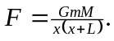 As x >> L, the denominator approaches 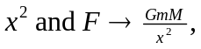 as expected. (This is an alternative but equivalent way of obtaining the result of part (b) Exercise 12.39.)

